Aches, pains or recent injury? Saco Bay Orthopaedic & Sports Physical Therapy is there for students and their families.

Saco Bay Orthopaedic &Sports Physical Therapy is the official athletic training services provider for Kennett High School. Our athletic trainers work as an extension of their sports team focusing on injury prevention, management and performance for your athletes.
Assisting your athletes
Saco Bay Orthopaedic & Sports Physical Therapy provides the best sports medicine support to your school. Our Conway location is a Select Sports Center of Excellence. This means it has demonstrated excellence in sports physical therapy treatment and is among only 100 national locations to bear this distinguished badge of honor. Our Centers of Excellence set the standard for excellence in recovery, injury prevention and athletic performance enhancement.
At the high school level, our athletic trainers are focused on three things:
- Being on-site, visible participants: We manage injuries, safety, performance and health of your athletes. We take care of injuries on the field, whether it’s first aid, head or neck injuries, cardiac issues or emergency care. We are proactive and make safety recommendations.
- Managing the athletic training room: We are on-site, order necessary supplies and create emergency action plans. After school, we evaluate students to determine who needs quick care, further evaluation and a referral to a physician or specialist. We also manage concussion programs to ensure your athletes receive concussion evaluation and treatment quickly.
- Coordinating appropriate care: If an athlete needs additional care or support, our team will connect them to physical therapists, physicians, nurses or psychologists.
Our athletic trainers are connected to a local center and have the support of physical and occupational therapists. We enhance that clinical connection with physical therapists who visit your school and act as a backup therapist providing informed, thoughtful advice on your program.
Meet your child’s athletic training team:
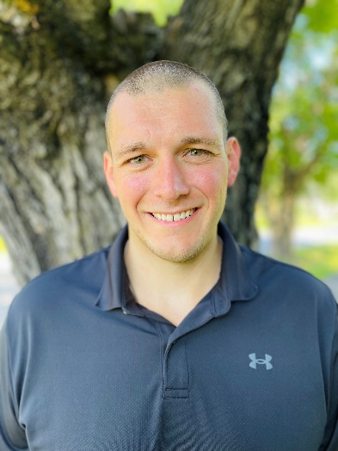
Colby Locke MS, ATC, LAT Head Athletic Trainer

Our nearby physical therapy centers offer services outside of sports medicine as well. With service offerings that include balance and dizziness, orthopedic rehabilitation and work conditioning, Saco Bay Orthopaedic & Sports Physical Therapy can help get the entire family back to what they love.
Experience the power of physical therapy at a center near you. Go to sacobaypt.com today!

